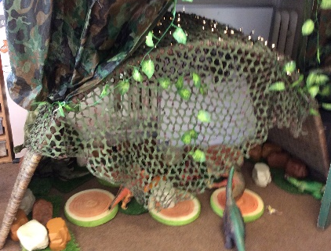
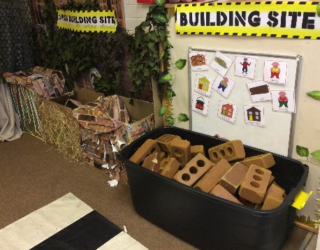
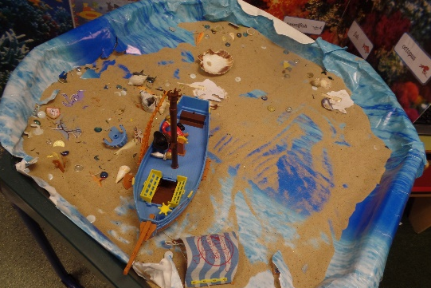
Communication and
Language
Area of Development | Autumn 1 Autumn 2 |  | Spring 1 Spring 2 |  |  | Summer 1 Summer 2
CAL | RECEPTION
 | - Understand how to listen carefully and why listening is important.  - Learn new vocabulary.  - Use new vocabulary through the day.  - Describe events in some detail.  - Develop social phrases.  - Engage in story times.  - Listen to and talk about stories to build familiarity and understanding.  - Retell the story, once they have developed a deep familiarity with the text; some as exact repetition and some in their own words.  - Use new vocabulary in different contexts.  - Listen carefully to rhymes and songs, paying attention to how they sound.  - Learn rhymes, poems and songs.  - Engage in non-fiction books. |  | - Learn new vocabulary  - Use new vocabulary through the day  - Ask questions to find out more and to check they understand what has been said to them.  - Articulate their ideas and thoughts in well  - formed sentences.  - Connect one idea or action to another using a range of connectives.  - Use talk to help work out problems and organise thinking and activities explain how things work and why they happen.  - Listen carefully to and learn rhymes, poems and songs, paying attention to how they sound.  - Listen to and talk about selected non-fiction to develop a deep familiarity with new knowledge and vocabulary. |  | - Use talk to help work out problems and organise thinking and activities explain how things work and why they might happen.  - Retell the story, once they have developed a deep familiarity with the text; some as exact repetition and some in their own words.
 |  |  |  |  | EARLY LEARNING GOALS
 |  |  |  |  | LISTENING, ATTENTION AND UNDERSTANDING |  | SPEAKING
 |  |  |  |  | - Listen attentively and respond to what they hear with relevant questions, comments and actions when being read to and during whole class discussions and small group interactions.  - Make comments about what they have heard and ask questions to clarify their understanding.  - Hold conversation when engaged in back-and-forth exchanges with their teacher and peers. |  | - Participate in small group, class and one-to-one discussions, offering own ideas, using recently introduced vocabulary.  - Offer explanations for why things happen, making use of recently introduced vocabulary from stories, non-fiction, rhymes and poems when appropriate.  - Express ideas and feelings about their experiences using full sentences, including use of past, present and future tenses and making use of conjunctions, with modelling and support from their teacher.
Role Play  Children given a choice with additional suggestions and interests considered. | Home Corner | Santa’s Workshop  Shop (Toy, Sweet,)  Dark Den  Witches Cottage  Potion Lab | Vets  Farm shop  Gift Shop  Jungle | Garage  Doctors surgery  Post office  Police Station  Space station |  | Castle  Café  Restaurant  Travel Agents  Airport |  | Garden Centre  Supermarket  Campsite  Ice cream parlour  Pirate Ship

