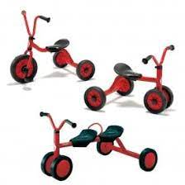
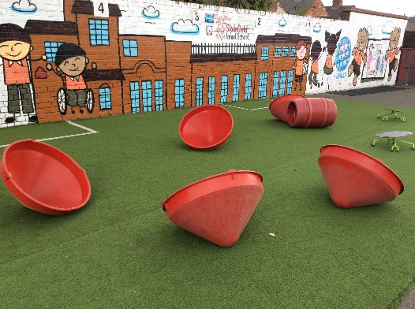
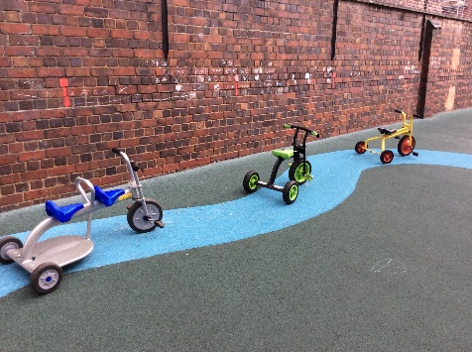
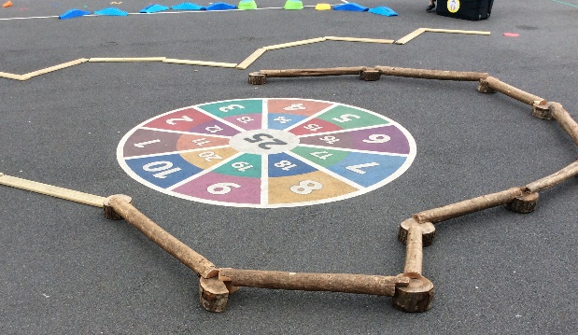
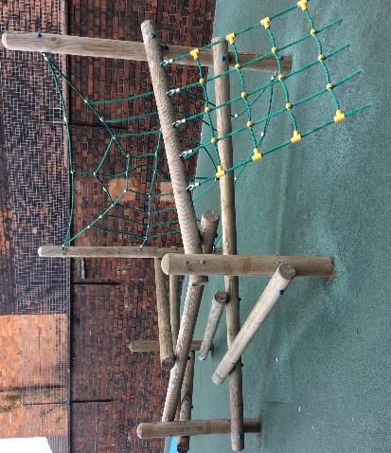
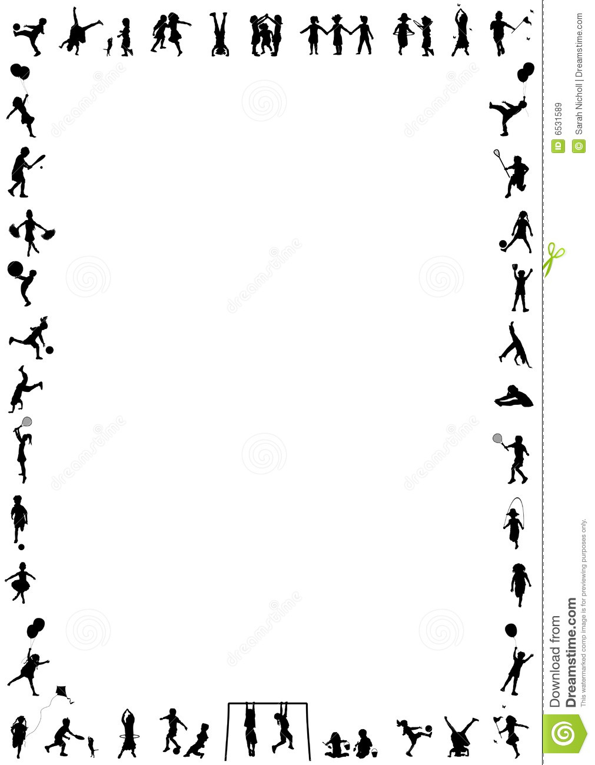
Physical

Area of Development | Autumn 1 Autumn 2 |  | Spring 1 Spring 2 |  |  | Summer 1 Summer 2
PHYSICAL | RECEPTION
 | - Revise and refine the fundamental movement skills they have already acquired: rolling, crawling, walking, jumping, running, hopping, skipping, climbing  - Develop their small motor skills so that they can use a range of tools competently, safely and confidently. Suggested tools: pencils for drawing and writing, paintbrushes, scissors, knives, forks and spoons.  - Use their core muscle strength to achieve a good posture when sitting at a table or sitting on the floor.  - Confidently and safely use a range of large and small apparatus indoors and outside, alone and in a group.  - Develop overall body-strength, balance, co-ordination and agility |  | - Further develop and refine a range of ball skills including: throwing, catching, kicking, passing, batting, and aiming.  - Develop the foundations of a handwriting style which is fast, accurate and efficient.  - Develop confidence, competence, precision and accuracy when engaging in activities that involve a ball.  - Combine different movements with ease and fluency  - Develop overall body-strength, balance, co-ordination and agility |  | - Progress towards a more fluent style of moving, with developing control and grace.  - Develop the overall body strength, co-ordination, balance and agility needed to engage successfully with future physical education sessions and other physical disciplines including dance, gymnastics, sport and swimming.  - Know and talk about the different factors that support their overall health and wellbeing: regular physical activity, healthy eating, tooth brushing, sensible amounts of ‘screen time’, having a good sleep routine, being a safe pedestrian  - Develop overall body-strength, balance, co-ordination and agility  - Further develop the skills they need to manage the school day successfully: lining up and queuing, mealtimes, personal hygiene.
 |  |  |  |  | EARLY LEARNING GOALS
 |  |  |  |  | GROSS MOTOR SKILLS |  | FINE MOTOR SKILLS
 |  |  |  |  | - Negotiate space and obstacles safely, with consideration for themselves and others.  - Demonstrate strength, balance and coordination when playing.  Move energetically, such as running, jumping, dancing, hopping, skipping and climbing. |  | - Hold a pencil effectively in preparation for fluent writing – using the tripod grip in almost all cases.  - Use a range of small tools, including scissors, paintbrushes and cutlery.  - Begin to show accuracy and care when drawing.
PE Sessions Mr Parkes | Baseline | Movement  Travelling | Ball skills | Dance |  | Gymnastics |  | Multiskills

