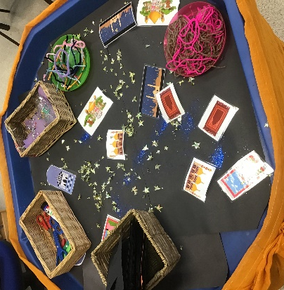
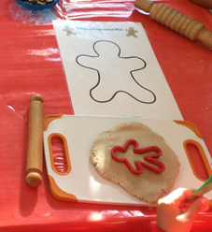
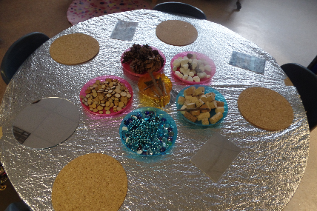
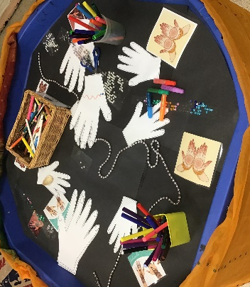
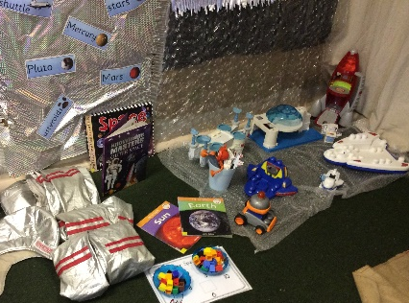
Expressive Art
and Design
Area of Development | Autumn 1 Autumn 2 |  | Spring 1 Spring 2 |  |  | Summer 1 Summer 2
EAD | RECEPTION
 | - Explore and use a variety of artistic effects to express their ideas and feelings.  - Sing in a group or on their own, increasingly matching the pitch and following the melody. (Makaton Carol Service)  - Develop storylines in their pretend play.  - Explore and engage in music making and dance. |  | - Explore, use and refine a variety of artistic effects to express their ideas and feelings.  - Return to and build on their previous learning, refining ideas and developing their ability to represent them.  - Create collaboratively sharing ideas, resources and skills.  - Sing in a group or on their own, increasingly matching the pitch and following the melody  - Explore and engage in music making and dance, performing solo or in groups. | - Explore and engage in music making and dance, performing solo or in groups. (Dance planning in P.E) (Easter Performance)  - Watch and talk about dance and performance art, expressing their feelings and responses.  - Return to and build on their previous learning, refining ideas and developing their ability to represent them.  - Listen attentively, move to and talk about music, expressing their feelings and responses.
 |  |  |  | EARLY LEARNING GOALS
 |  |  |  | CREATING WITH MATERIALS |  |  | BEING IMAGINATIVE
 |  |  |  | - Safely use and explore a variety of materials, tools and techniques, experimenting with colour, design, texture, form and function.  - Share their creations, explaining the process they have used.  - Make use of props and materials when role playing characters in narratives and stories. |  |  | - Invent, adapt and recount narratives and stories with peers and their teacher.  - Sing a range of well-known nursery rhymes and song  - Perform songs, rhymes, poems and stories with others, and (when appropriate) try to move in time with music.
Charanga | Me!  Learn to sing nursery rhymes and action songs: Pat-a-cake ·  1, 2, 3, 4, 5, Once I Caught a Fish Alive ·  This Old Man  Five Little Ducks | My Stories  Learn to sing nursery rhymes and action songs:  I’m A Little Teapot  The Grand Old Duke of York  Ring O’ Roses  Hickory Dickory Dock | Everyone  Learn to sing nursery rhymes and action songs:  Wind The Bobbin Up  Rock-a-bye Baby  Five Little Monkeys  Twinkle Twinkle  If You're Happy and You Know It  Head, Shoulders, Knees and Toes | Our World  Learn to sing nursery rhymes and action songs:  Old Macdonald  Row, Row, Row Your Boat  The Wheels On the Bus  Incy Wincy Spider  Baa Baa Black Sheep | Big Bear Funk  Big Bear Funk is a transition Unit that prepares children for their musical learning in Year 1. |  | Reflect, Rewind and Replay  Consolidate learning and perform. This Unit of Work consolidates the learning that has occurred during the year. All the learning is focused around revisiting chosen nursery rhymes and/or songs, a context for the History of Music and the very beginnings of the Language
EAD  Continuous | Collage using natural resources.  Collage using different materials.  Self portraits  Leaf prints  Making own alternatives to plastic bags. | Create Diwali/Firework inspired art using different media for example powder paint, liquid chalk, chalk.  Night Painting using different textures e.g. Add flour, sand etc. to paint. (moon and stars)  Snowy pictures using colour mixing. Shades of blue and grey by adding white.  Making Christmas decorations, Christmas cards and calendars.  Learning Christmas Carols with Makaton. | Painting farm scenes  Making animal puppets e.g. stick puppets and sock puppets.  Cat/dog creative craft using paper plates.  Animal patterns.  Making Musical instruments (junk modelling). | Junk modelling rockets/spaceships/trucks  Designing space scene using range of media and materials.  Making resources for Police/ fire service role play. | Oil pastel portraits of the Queen.  Van Gogh and Leonardo da Vinci artist study – Pointillism.  Constructing bridges and small world models.  Large scale junk modelling of London landmarks. |  | Shell drawings/rubbings.  Under the sea craft, Tinfoil art, Making a Sea Scene, tissue paper jelly fish.  Vegetable printing.  Colour mixing, bubble painting.  Flower pressing.  Making puppets.  Making Supertato models and designing superheroes.  Decorating smile stones.

