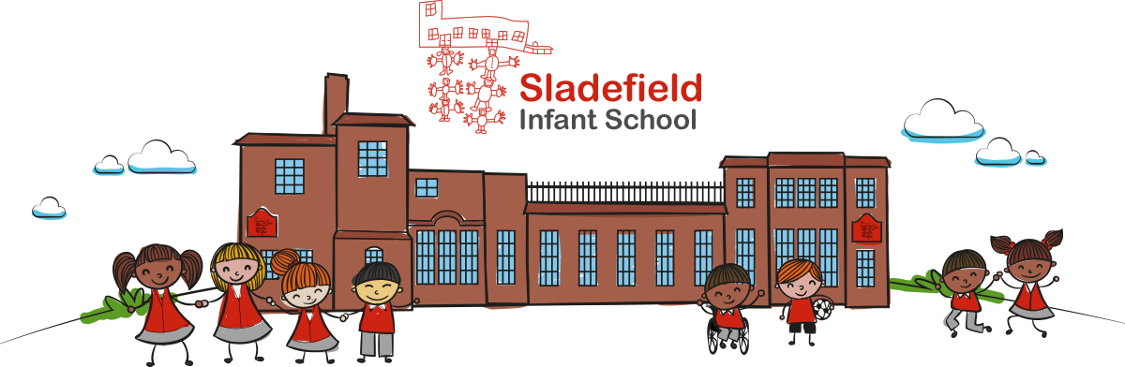

Be happy, be healthy, be safe, always do your best!
SLADEFIELD INFANT SCHOOL
Social Media Policy
 | Committee | Date | Minute No.
Reviewed and Approved by Governors | C & GP | 06.10.14 | 6
Reviewed and Approved by Governors | C & GP | 17.10.16 | 8
Reviewed and Approved by Governors | FGB | 27.03.18 | 15
Reviewed and Approved by Governors | FGB | 23.03.20 | 12
Reviewed and Approved by Governors
Reviewed and Approved by Governors
Reviewed and Approved by Governors
Reviewed and Approved by Governors
Reviewed and Approved by Governors
Reviewed and Approved by Governors

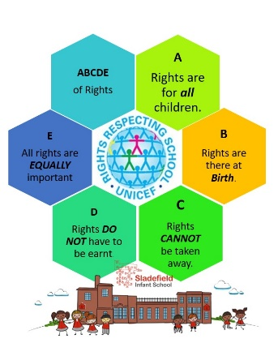
Social Media Policy
March 2022

The contents and guidelines outlined in this Social Media Policy link with the following UN Convention on the Rights of the Child Articles:

Article 13
(freedom of expression) ‘Every child has to be free to express their thoughts and opinions and to access all kinds of information, as long as it is within the law.’

Article 14
(freedom of thought, belief and religion) ‘Every child has the right to think and believe what they choose…as long as they are not stopping other people from enjoying their rights.’

Article 15
(freedom of association) ‘Every child has the right to meet with other children and to join groups and organisations, as long as this does not stop other people from enjoying their rights.’

Article 16
(right to privacy) ‘Every child has the right to privacy…including protecting…from unlawful attacks that harm their reputation.’

Article 17
(access to information from the media) ‘Every child has the right to reliable information from a variety of sources, and governments should encourage the media to provide information that children can understand. Governments must help protect children from materials that could harm them.’

Article 18
(parental responsibilities and state assistance) ‘… parents (have a) responsibility for bringing up their child and should always consider what is best for the child.’

Article 19
(protection from violence, abuse and neglect) ‘Governments must do all they can to ensure that children are protected from all forms of violence, abuse, neglect and bad treatment by their parents or anyone else who looks after them.’

Introduction
This Social Media Policy provides clarity on the way social media sites are to be used by Sladefield Infant School community: pupils, staff, parents, carers, governors and other volunteers. It must be used by all staff to ensure that our children are safe and secure.

Sladefield Infant School understands that Social Media is a growing part of life outside of school, our children are too young to have their own social media account, but we feel it is important that we teach them about social media platforms.

Sladefield Infant School has a commitment to safeguarding children in all aspects of its work. As part of this commitment, we have a responsibility to safeguard our pupils against potential dangers when accessing the Internet at school, and to educate our stakeholders about how to protect themselves online when outside of school. This policy has been written to set out the key principles and code of conduct that we expect of all members of staff, pupils, parents/carers, and other adults associated with the school with respect to their responsibilities in connection with the use of Social Media

Aims of the Policy
- To ensure that the confidentiality of pupils and staff and the reputation of the school are safeguarded
- To recognise that social media present significant opportunities to communicate within the school and across the wider community, but that they also present unique risks
- To enable pupils and parents to have confidence in the school’s decisions and services
- To ensure staff members and governors use social media responsibly

Key roles and responsibilities
- The Governing Body has overall responsibility for the implementation of the Social Media Policy and procedures of Sladefield Infant School
- The Governing Body has responsibility for ensuring that the Social Media Policy, as written, does not discriminate on any grounds, including but not limited to: ethnicity/national origin, culture, religion, gender, disability or sexual orientation.
- The Governing Body has responsibility for handling complaints regarding this policy as outlined in the school’s Complaints Policy.
- The Head Teacher will be responsible for the day-to-day implementation and management of the Social Media Policy and procedures of Sladefield Infant School.
- Staff, including teachers and support staff, and non-staff visitors to the school, including volunteers and students, will be responsible for following the Social Media Policy and for ensuring pupils do so also. They will also be responsible for ensuring the policy is implemented fairly and consistently in the classroom.
- Parents and carers will be expected to take responsibility for the Social Media habits of their child/children at home.
- Parents and carers will be expected to promote safe Social Media behaviour.
Definitions
- Sladefield Infant School defines ‘Social Media’ as any online platform that offers real-time interaction between the user and other individuals or groups including, but not limited to:
- Blogs.
- Online discussion forums, such as netmums.com.
- Collaborative spaces, such as Facebook, Class Dojo & Tapestry
- Media sharing services, such as YouTube, Class Dojo & Tapestry.
- ‘Micro-blogging’ applications, such as Twitter.
- Sladefield Infant School defines ‘cyber-bullying’ as any use of social media or communication technology to bully an individual or group.
- Sladefield Infant School defines ‘members of the school community’ as any teacher, member of support staff, pupil, parent/carer of pupil, Governor, regular visitor, student, volunteer or ex-pupil.

The use of social media sites by pupils
- Pupils cannot access social networking sites at school, the firewalls in school protect them from this.
- Parents will be reminded that the use of social media sites is inappropriate for infant-aged pupils

Use of social media sites by employees in a personal capacity
Staff will be advised as follows:
- That they familiarise themselves with social network sites’ privacy settings in order to ensure that information is not automatically shared with a wider audience than intended.
- That they do not conduct or portray themselves, or allow friends to portray them, in a manner which may:
  - bring the school into disrepute
  - lead to valid parental complaints
  - be deemed as derogatory towards the school and/or its employees
  - be deemed as derogatory towards pupils, parents/carers or governors
  - bring into question their appropriateness to work with children
  - contravene the Teacher Standards
- That they do not form online friendships or enter into communication with parents/carers as this could lead to professional relationships being compromised.
- That they do not form online friendships or enter into online communication with pupils as this could lead to professional relationships being compromised, and/or safeguarding allegations being raised.
- That they should not post pictures of school events (without the Headteacher’s consent)
- That they should not post negative comments about school events.
- That if their use of social media/networking sites contravenes this policy, they may be subject to disciplinary action
Comments posted by parents/carers and wider family members on social media sites
- Parents/carers will be made aware of their responsibilities regarding their use of social media via this policy, when their child joins the school, the school website and workshops which are held regularly.
- Parents/carers and wider family members are asked not to post images (photos and videos) of pupils other than their own children/relatives on social media sites unless they have the permission of the parents of other children pictured
- Family members are asked to raise queries, concerns or complaints directly with the school rather than posting them on social media
- Parents/carers and wider family members should not post comments on social media sites about any member of the school community

Training of staff
- At Sladefield Infant School, we recognise that early intervention can protect pupils who may be at risk of cyber-bullying or negative Social Media behaviour. As such, teachers and support staff will receive training in identifying potentially at-risk pupils.
- Teachers and support staff will receive training on the Social Media Policy as part of their New Starter Induction.
- Teachers and support staff will receive regular and ongoing training as part of their development using the National Online Safety platform.

Cyber bullying
- At Sladefield Infant School, due to the age of the children at the school, it is less likely that cyber-bullying between pupils will take place; irrespective of this fact, cyber bullying is still taken seriously and will not be tolerated.
- Incidents of cyber bullying will be dealt with and reported along the same processes as indicated in the Anti-Bullying Policy.
- Staff members should never respond or retaliate to cyberbullying incidents. Incidents should instead be reported as inappropriate, and support sought from their Line Manager or a member of the School Leadership Team.
- Evidence from the incident should be saved, including screen prints of messages or web pages, and the time and date of the incident.
- Where the perpetrator is a current pupil or colleague, most cases can be dealt with through the school’s own disciplinary procedures.
- Where the perpetrator is an adult, in nearly all cases, a member of the School Leadership Team should invite the victim to a meeting to address their concerns. Where appropriate, the perpetrator will be asked to remove the offensive content. If the perpetrator refuses to comply, it is at the discretion of the school as to what next steps should be taken. This could include contacting the internet service provider in question through their reporting mechanisms, if the offensive content breaches their terms and conditions.
- If the material is threatening, abusive, sexist, of a sexual nature or constitutes a hate crime, the school will consider contacting the Police.
- As part of our on-going commitment to the prevention of cyber-bullying, regular education and discussion about e-safety will take place as part of Computing and PSHE.

10. Be SMART online
We encourage pupils to take a SMART approach to social media behaviour:

- Safe - Do not give out personal information, or post photos of yourself to people you talk to online. Follow age restriction rules.
- Meeting - Do not meet somebody you have only met online. We encourage parents/carers to speak regularly to their children about who they are talking to online.
- Accepting - We advise that pupils only open emails and other forms of communication from people they already know.
- Reliable - We teach pupils about the dangers of believing everything they see online.
- Tell - We encourage pupils to tell a teacher, parent or carer if they see anything online that makes them feel uncomfortable.

Nicola Connolly (Deputy Head Teacher)
March 2022

Review date: March 2024

