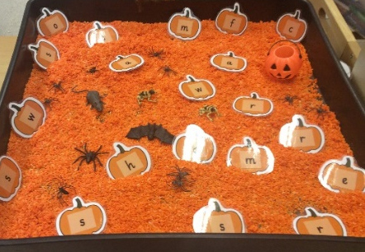
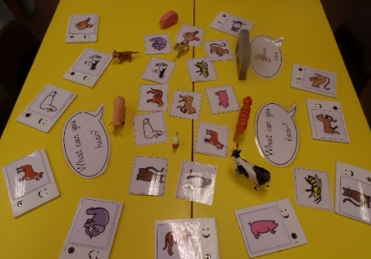
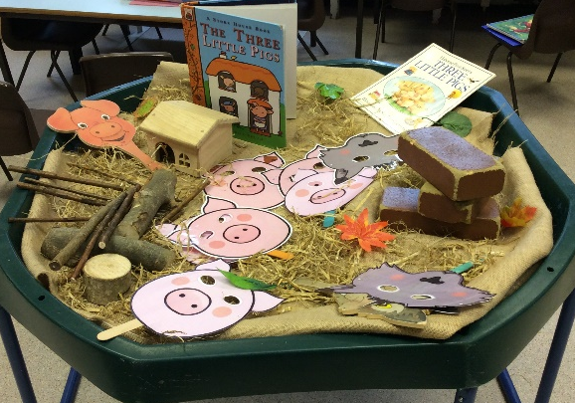
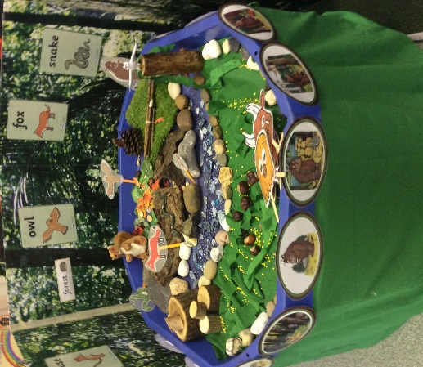
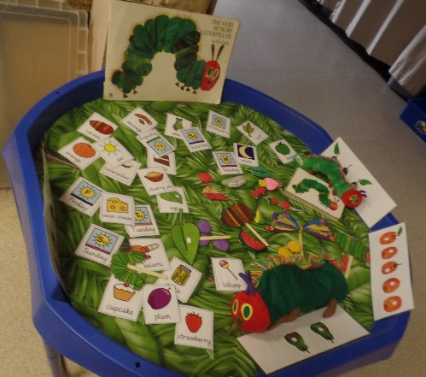
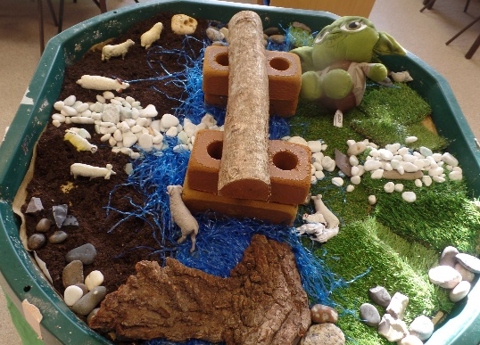

Literacy
Area of Development | Autumn 1 Autumn 2 | Spring 1 Spring 2 |  |  | Summer 1 Summer 2
Literacy | RECEPTION
 | Phase 2  - Read individual letters by saying the sounds for them.  - Blend sounds into words, so that they can read short words (CVC) made up of known letter-sound correspondences.  - Read a few common exception words matched to the school’s phonic programme. | Phase 3  - Blend sounds into words, so that they can read short words made up of known letter-sound correspondences.  - Read some letter groups that each represent one sound and say sounds for them.  - Begin to read simple phrases and sentences made up of words with known letter–sound correspondences and, where necessary, a few exception words.  - Spell words by identifying the sounds and then writing the sound with letter/s.  - Re-read what they have written to check that it makes sense.  - Form lower-case letters correctly. | Phase 3 and 4  - Read simple phrases and sentences made up of words with known letter–sound correspondences and, where necessary, a few exception words.  - Re-read books to build up their confidence in word reading, their fluency and their understanding and enjoyment.  - Spell words by identifying the sounds and then writing the sound with letter/s.  - Form lower-case and capital letters correctly.  - Write short sentences with words with known letter-sound correspondences using a capital letter and full stop.  - Re-read what they have written to check that it makes sense.
 |  |  | EARLY LEARNING GOALS
 |  |  | COMPREHENSION | WORD READING |  | WRITING
 |  |  | - Demonstrate understanding of what has been read to them by retelling stories and narratives using their own words and recently introduced vocabulary.  - Anticipate (where appropriate) key events in stories.  - Use and understand recently introduced vocabulary during discussions about stories, non-fiction, rhymes and poems and during role play. | - Say a sound for each letter in the alphabet and at least 10 digraphs.  - Read words consistent with their phonic knowledge by sound-blending.  - Read aloud simple sentences and books that are consistent with their phonic knowledge, including some common exception words. |  | - Write recognisable letters, most of which are correctly formed.  - Spell words by identifying sounds in them and representing the sounds with a letter or letters.  - Write simple phrases and sentences that can be read by others.

 | Autumn 1 | Autumn 2 | Spring 1 | Spring 2 | Summer 1 | Summer 2
Writing | Introduction to the mighty writer  Traditional tales story  retells  Initial Sounds  Name writing | Changing a character of a familiar story for the mighty writer  Labelling pictures with CVC words  Toy lists  Story sequencing  Letters  CVC words  Spell lists | Rhyming Words  Character description using simple sentences  Drawing Story maps  Simple sentences to retell stories and events  Changing the ending of a story | Invitation to a tea  party  Speech Bubbles  Shopping list for a picnic | Fact book on London  Birthday Cards  Holiday retell  Eid cards  Writing words with digraphs and trigraphs  Writing simple sentences using full stops and capital letters.  Labelling story map  Story retell | Writing sentences using digraphs and trigraphs taught  Story retell  Writing own stories  Instructions  Fact file on the sea  Performing rhymes and poems
Role-play  Suggestions | Home Corner | Santa’s Workshop  Shop (Toy, Sweet,)  Dark Den  Witches Cottage /Potion Lab | Vets  Farm shop  Gift Shop  Jungle | Garage  Doctors surgery  Post office  Police Station | Castle  Café  Restaurant  Travel Agents /Airport | Garden Centre  Campsite  Ice cream parlour  Pirate Ship
Books to support topic | Traditional Tales  Goldilocks and the Three Bears  The Gingerbread Man  Jack and the Beanstalk  Black History Month  One Plastic Bag  Henrys Freedom Box  Little People Big Dreams Wilma Rudolph  Wangari’s Trees of Peace.  The Water Princess | Light and Dark  Meg and Mog  Rama and Sita – The Story of Diwali  Anti-Bullying  Giraffes Can’t Dance  Winter  Lost and Found  Stickman  Frozen Fever (Visual Literacy)  The Christmas Story | Mick and Chloe Inkpen  I Will Love You Anyway  The Great Pet Sale  Zoe and Beans  Wibbly Pig  Hole in the Zoo  Baggy Brown  This Is My Book  Animal Stories  Dear Zoo  The Tiger Who Came to Tea  Brown Bear, Brown Bear | People Who Help Us  I’m Afraid Your Teddy Is In Trouble Today  Busy People Book  Emergency  Transport  The Jolly Postman  Duck in a Truck  Whatever Next  Mr Gumpys Outing  Easter  Puddles and the Happy Easter Day | London  The Queens Hat  The Queens Handbag  Katie in London  Scotland  Katie in Scotland  Italy  Katie and the Mona Lisa  Netherlands  Katie and the Starry Night  Once Upon a Time | Parks and Gardens  The Enormous Turnip  Supertato  Handa’s Surprise  Shark in the Park  The Very Hungry Caterpillar  The Sea  Barry the Fish with Fingers  Rainbow Fish  Toy Boat  Seaside Poems  Pirate Pet

