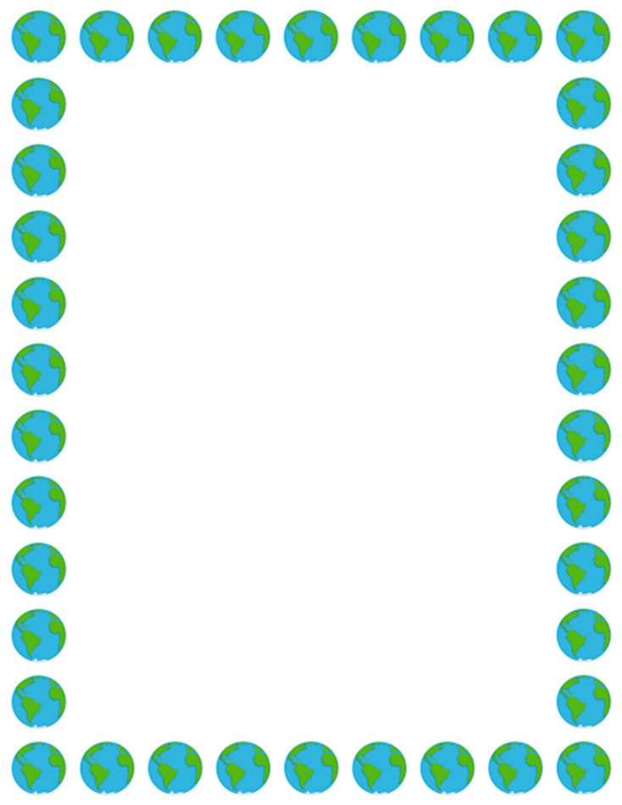
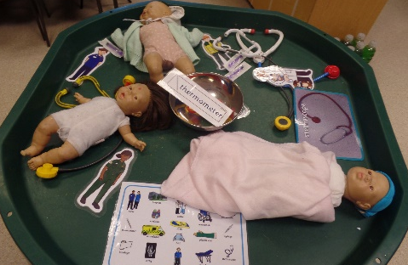
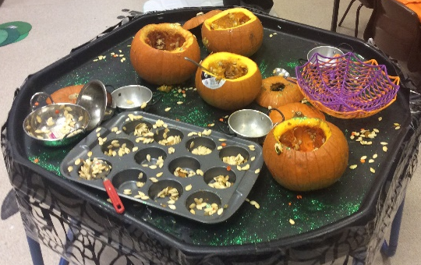
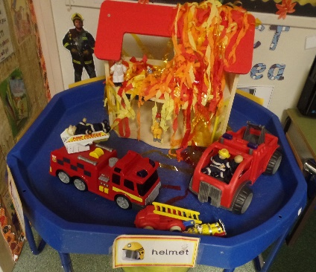
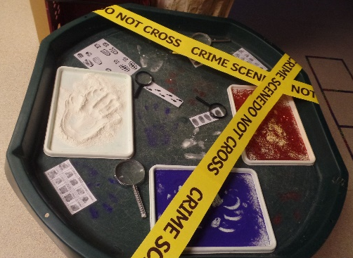
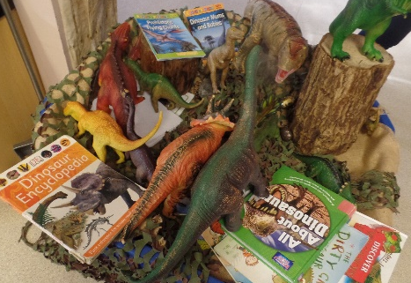
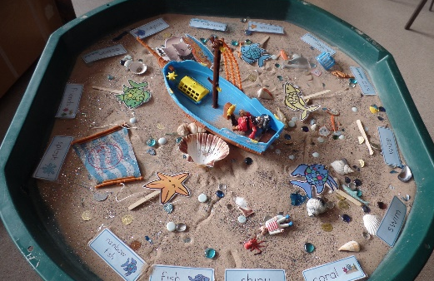

Understanding the World
Area of Development | Autumn 1 Autumn 2 |  | Spring 1 Spring 2 |  |  | Summer 1 Summer 2
UTW | RECEPTION
 | - Talk about members of their immediate family and community.  - Name and describe people who are familiar to them.  - Comment on images of familiar situations in the past.  - Compare and contrast characters from stories, including figures from the past.  - Recognise that people have different beliefs and celebrate special times in different ways.  - Understand the effect of changing seasons on the natural world around them. |  | - Draw information from a simple map.  - Understand that some places are special to members of their community.  - Recognise that people have different beliefs and celebrate special times in different ways.  - Understand the effect of changing seasons on the natural world around them.  - Explore the natural world around them. | - Draw information from a simple map.  - Describe what they see, hear and feel whilst outside.  - Recognise some similarities and differences between life in this country and life in other countries.  - Recognise some environments that are different to the one in which they live.  - Understand the effect of changing seasons on the natural world around them.
 |  |  |  | EARLY LEARNING GOALS
 |  |  |  | PAST AND PRESENT | PEOPLE, CULTURE AND COMMUNITIES |  | THE NATRUAL WORLD
 |  |  |  | - Talk about the lives of the people around them and their roles in society.  - Know some similarities and differences between things in the past and now, drawing on their experiences and what has been read.  - Understand the past through settings, characters and events encountered in books read in class and storytelling. | - Describe immediate environment using knowledge from observation, discussion, stories, non-fiction texts and maps.  - Know similarities and differences between religious and cultural communities in this country, drawing on experiences and what has been read in class.  - Explain similarities and differences between life in this country and life in other countries. |  | - Explore the natural world around them, making observations and drawing pictures of animals and plants.  - Know some similarities and differences between the natural world around them and contrasting environments.  - Understand some important processes and changes in the natural world (seasons, states of matter)
UTW  Continuous | My family pictures  Investigating nature in Autumn.  Environment – effects of plastic on the environment. Recycling.  Exploring materials and their uses. | Light and dark discussion linked to times of the day and seasons. Light box pictures.  Freezing melting of ice, butter and chocolate using a microwave.  Countries that are cold all year round  Use a map to find the North and South poles - add penguins, polar bears to the map.  Weather – clothing.  Season of winter – similarities and differences, comparison with other seasons. | Old and New Toys, similarities and differences.  Finding out about farms. What food comes from each animal? Sort different foods into where it comes from.  Matching animals to their babies.  Maps – finding out where animals live and their different habitats.  Lifecycle of a chick and/caterpillar  Taking care of animals. | Easter celebrations Easter bonnets, egg hunts.  People who help us: The role of the Police and Firefighters.  The first Moon Landing. | The Queen’s Life from young to old. Link with ‘when I was a baby’.  How Eid is celebrated and compare and contrast with Easter.  Finding England and Scotland on a map of the UK.  Compare life in England to life in Italy |  | Planting seeds/beans.  Designing and making miniature gardens  Looking closely at and exploring plants and vegetables. (chopping vegetables, exploring root growth, conditions for growth, decay.  Environmental senses what can I hear, etc.  Observing the lifecycle of a caterpillar.  Floating and Sinking Making and testing something that floats (boats, rafts).

