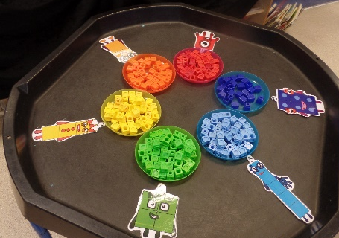
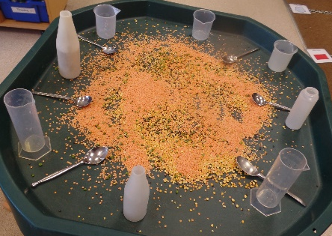
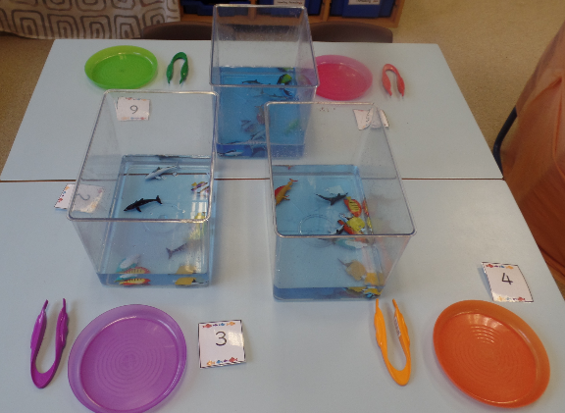
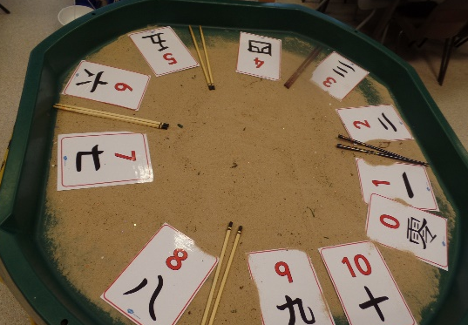
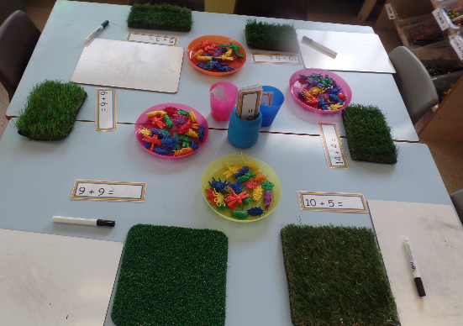
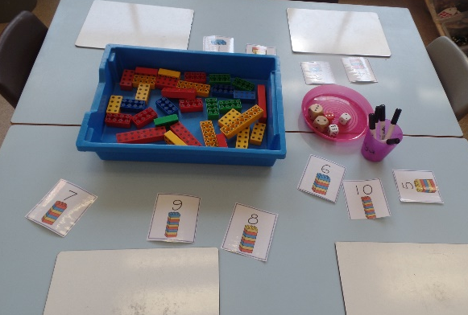

Maths
Area of Development | Autumn 1 Autumn 2 |  |  | Spring 1 Spring 2 |  |  |  | Summer 1 Summer 2
Maths | RECEPTION
 | - Count objects, actions and sounds.  - Subitise.  - Link the number symbol (numeral) with its cardinal number value  - Count beyond ten orally.  - Compare numbers  - Understand the ‘one more than/one less than’ relationship between consecutive numbers.  - Explore the composition of numbers to 5. |  |  | - Automatically recall number bonds for numbers 0–10.  - Select, rotate and manipulate shapes in order to develop spatial reasoning skills.  - Compose and decompose shapes so that children recognise a shape can have other shapes within it, just as numbers can.  - Explore the composition of numbers to 10.  - Subitise.  - Explore the composition of numbers to 10. |  |  | - Compare length, weight and capacity.  - Continue, copy and create repeating patterns.  - Automatically recall number bonds for numbers 0–10.  - Count beyond ten.
 |  |  |  |  |  |  | EARLY LEARNING GOALS
 |  |  |  |  |  |  | NUMBER |  |  |  | NUMERICAL PATTERNS
 |  |  |  |  |  |  | - Have a deep understanding of number to 10, including the composition of each number.  - Subitise (recognise quantities without counting) up to 5.  - Automatically recall (without reference to rhymes, counting or other aids) number bonds up to 5 (including subtraction facts) and some number bonds to 10, including double facts |  |  |  | - Verbally count beyond 20, recognising the pattern of the counting system.  - Compare quantities up to 10 in different contexts, recognising when one quantity is greater than, less than or the same as the other Quantity`.  - Explore and represent patterns within numbers up to 10, including evens and odds, double facts and how quantities can be distributed equally
Power Maths | 1 | Number  number and place value | Counting to 1,2,3 | 1 | Number bonds to 5 | Introducing the part-whole model |  |  | 1 | Exploring patterns |  | Making simple patterns
 | 2 |  | Counting to 4 | 2 | Numbers to 10 | Counting to 6,7 and 8 |  |  | 2 |  |  | Exploring more complex  patterns
 | 3 |  | Counting to 5 | 3 |  | Counting to 9 and 10 |  |  | 3 | Counting on and back |  | Add by counting on
 | 4 | Number addition and subtraction | Sorting into 2 groups | 4 | Comparing  numbers within 10 | Comparing groups up to 10 |  |  | 4 |  |  | Taking away by counting back
 | 5 | Number and place value | Comparing quantities of identical objects | 5 | Addition to 10 | Combining two groups to find the whole |  |  | 5 | Numbers to 20 |  | Counting to 20
 | 6 |  | Comparing quantities of non- identical objects | 6 | Number bonds  to 10 | Using a ten frame |  |  | 6 | Numerical patterns |  | Doubling
 | 7 | Number addition and subtraction | One more | 7 |  | The part whole model to 10 |  |  | 7 |  |  | Halving and sharing
 | 8 |  | One less | 8 | Shape and space | Spatial awareness |  |  | 8 |  |  | Odds and evens
 | 9 | Time | Time | 9 |  | 3D Shapes |  |  | 9 | Measure |  | Length, height  and distance
 |  |  |  | 10 |  | 2D Shapes |  |  | 10 |  |  | Weight
 |  |  |  |  |  |  |  |  | 11 |  |  | Volume and capacity

